**ROC AND AREA UNDER THE CURVE**

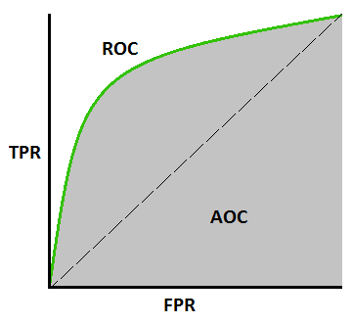

ROC is commonly way to visualize the performace of binary classifier

Binary classfier means a classifier having 2 possible output classes.

For Example:you made a classifer which will the predict wheather u will pass in exam or not based on various variables,the response or the output variable will wheather u will pass or u will not pass in exam

So for this types of prediction and classficition we will use algorithm such as logistic regression,so what logistic regression model will predict `wheather it will pass or not the exam based on some thresold value or prediction value that about this pass or fail

So by default thresold =50% is taken by the algorithm and for that model classification rate or present will be 90% correct but when there is overlapping between them model classificatin accuray will decrese

1. This is an ideal situation. When two curves don’t overlap at all means model has an ideal measure of separability. It is perfectly able to distinguish between positive class and negative class.
2. When two distributions overlap, we introduce type 1 and type 2 error. Depending upon the threshold, we can minimize or maximize them. When AUC is 0.7, it means there is 70% chance that model will be able to distinguish between positive class and negative class.
3. This is the worst situation. When AUC is approximately 0.5, model has no discrimination capacity to distinguish between positive class and negative class.
4. When AUC is approximately 0, model is actually reciprocating the classes. It means, model is predicting negative class as a positive class and vice versa.

As as we discussed above roc curve is way to visualize the performance of binary classifier by ploting grapgh between true positive rate and false positive rate

As u knw True positive rate answer the question when classifier is positive and false positive rate answer the question when classifer prediction to be negative

ROC curve plot a graph having true positive and false psoitive rate by will we can choose the best fit thresold value which give us less false postive rate with high true positive rate

**AUC CURVE**

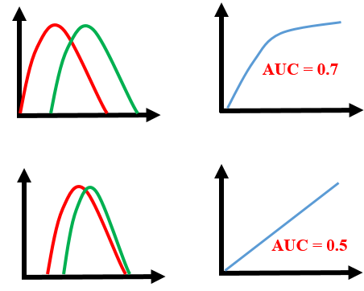

AUC curve represent the degree or measure of separabilty that is how much model is capable of distinguishy the classes,Higher the AUC better is the model

Value of AUC lie between 0 and 1,if a model is having AUC 1 the model is considered as to be the best model of seprarbility In fact it means it is reciprocating the result. It is predicting 0s as 1s and 1s as 0s. And when AUC is 0.5, it means model has no class separation capacity whatsoever.